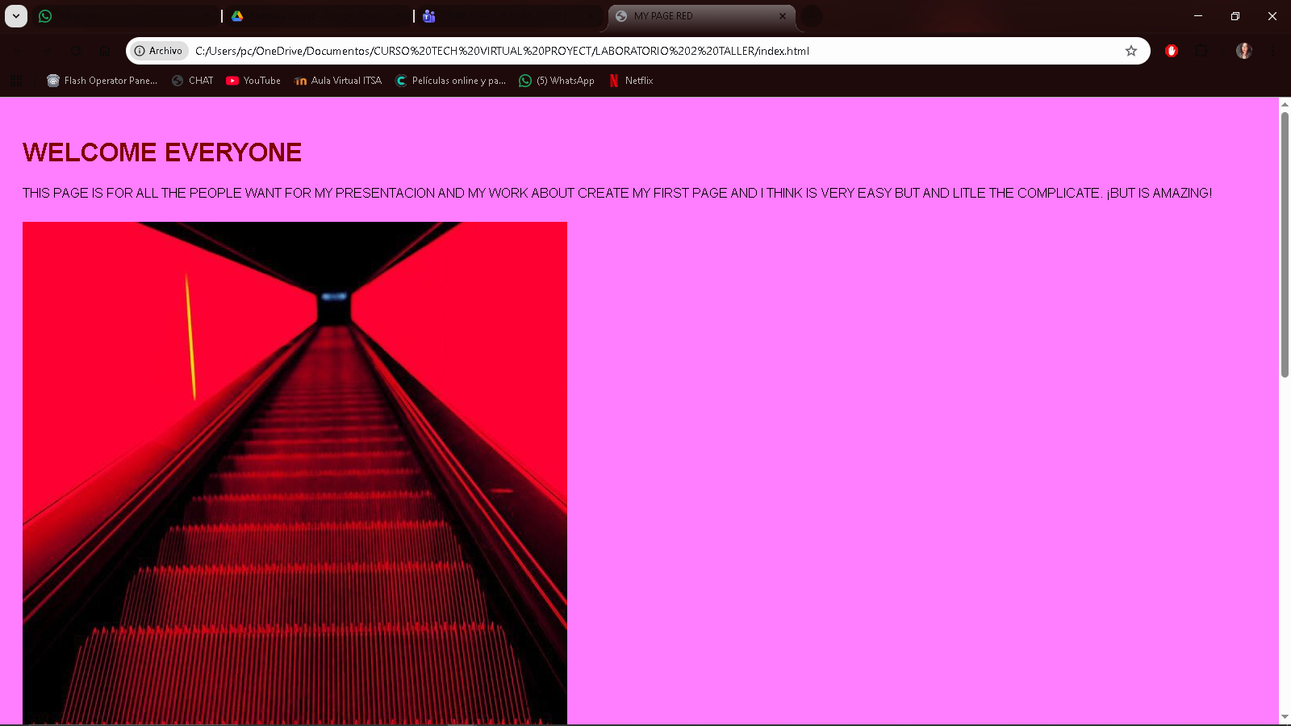
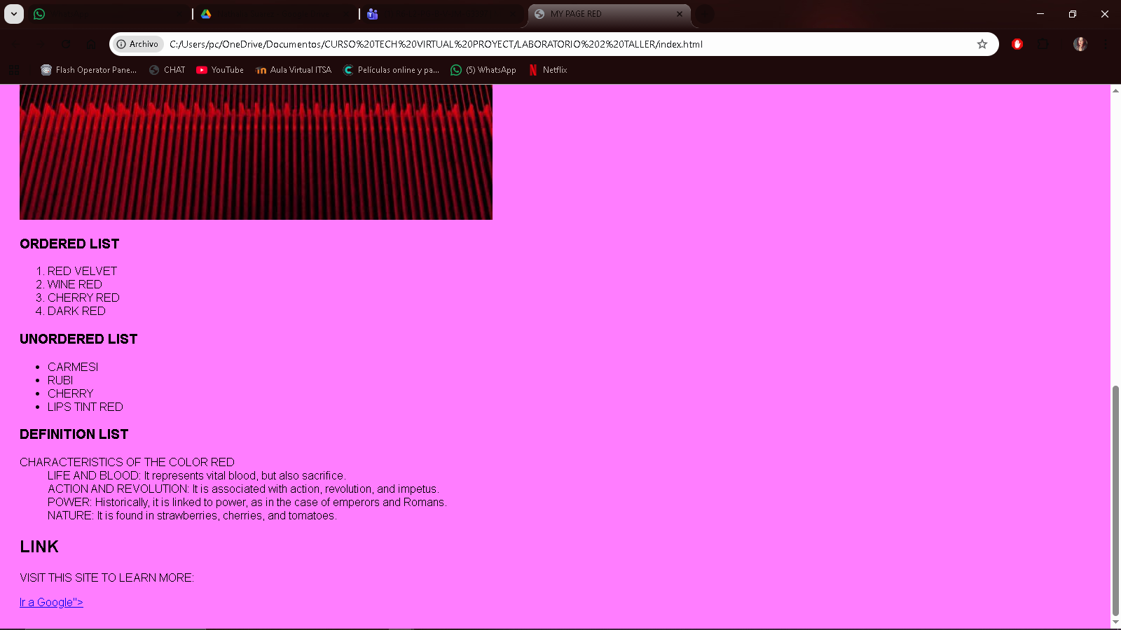

<!DOCTYPE html>
<html lang="es">
<head>
<meta charset="UTF-8">
<meta name="viewport" content="width=device-width, initial-scale=1.0">
<title>MY PAGE RED</title>
<link rel="stylesheet" href="styles.css">
<h1>
WELCOME EVERYONE
</h1>
</head>
<body>
<P> THIS PAGE IS FOR ALL THE PEOPLE WANT FOR MY PRESENTACION
AND MY WORK ABOUT CREATE MY FIRST PAGE AND I THINK
IS VERY EASY BUT AND LITLE THE COMPLICATE.
¡BUT IS AMAZING!

</P>
<img src="c:\Users\pc\Downloads\a000edc98b40ac0ad5096d78e2b68df0.jpg" alt="I LOVE IT RED" srcset="">
<h3>ORDERED LIST</h3>
<ol>
<li>RED VELVET</li>
<li>WINE RED</li>
<li>CHERRY RED</li>
<li>DARK RED</li>
</ol>
<H3>UNORDERED LIST</H3>
<ul>
<li>CARMESI</li>
<li>RUBI</li>
<li>CHERRY</li>
<li>LIPS TINT RED</li>
</ul>
<h3>DEFINITION LIST</h3>
<dl>
<dt>CHARACTERISTICS OF THE COLOR RED</dt>
<dd>LIFE AND BLOOD: It represents vital blood, but also sacrifice.</dd>
<dd>ACTION AND REVOLUTION: It is associated with action, revolution, and impetus.</dd>
<dd>POWER: Historically, it is linked to power, as in the case of emperors and Romans.</dd>
<dd>NATURE: It is found in strawberries, cherries, and tomatoes.</dd>
</dl>
<H2>LINK</H2>
<P>VISIT THIS SITE TO LEARN MORE:</P>
<a href="href=//www.google.com" target="_blank">Ir a Google"></a>
</body>

</html>

